**April Newsletter**

Rm 5 and 6 Ms Courtney Ms Arianna



Remington & Spencer-Ann

**This Month We Will Explore**

**~** Easter

~ Earth Day

~Flowers / Insects



**Special Events**

Picture Day 4/2 and 4/3

**Featured Book**

** **

**Featured Songs**

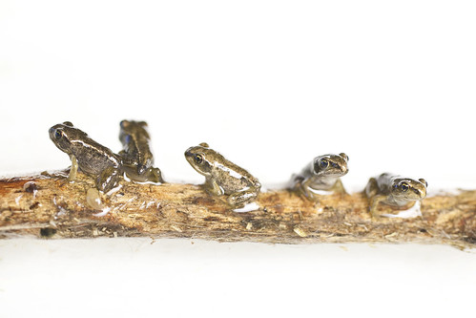

**Five Little Speckled Frogs**



Kingston

**Letters Of The Month: VWX**

**Number Of The Month: 9 & 10**

**Color Of The Month: Black & White**

**Shape Of The Month: Oval**

