Monday | Tuesday | Wednesday | Thursday | Friday
4  Dr. Seuss Crafts and Activities  Letters Uu & Qq  Number 18 | 5  Dr. Seuss Crafts and  Activities | 6  Dr. Seuss Crafts and Activities | 7  Dr. Seuss Crafts and  Activities | 8  Dr. Seuss and  Activities
11  Letter Jj  Number 19  Things Change | 12  Life Cycle of a Frog | 13  Life Cycle of a Chicken | 14  Life Cycle of a Butterfly | 15  St Patrick’s Day  LET’S CATCH A LEPRECHAUN!
18  Letter Zz  Number 20  Look at Us | 19  Spanish review | 20  Spanish review | 21  Spanish review | 22  Spanish review
25  Alphabet review  Number 20 | 26  Practice the Letter’s Sounds | 27  1-20 review | 28  Star fall Activities time | 29  Dino Lingo Games Activities
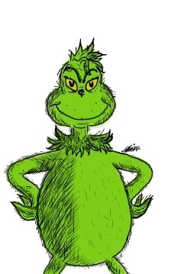
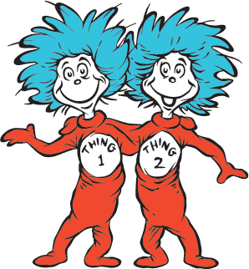
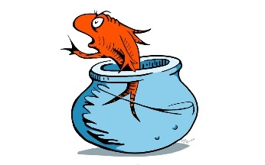
Room 8 Ms. Bianca March 2024

