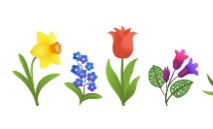
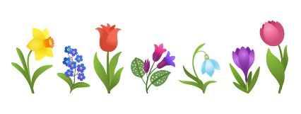
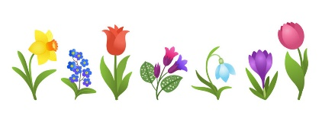
Spring Break 2024
Monday | Tuesday | Wednesday | Thursday | Friday
March 25  Handprint  Dandelions  Jellybean  Building | 26  Bunny Flowerpots  Jellybean Science Experiment | 27  Planting Alyssum Flowers  Coloring Changing Flowers | 28  Pipe Cleaner  Butterflies  Easter Egg  Make Rockets | 29  Spring I-Spy  Egg Drop  Experiment  Easter Egg Hunt  Bring 6 filled eggs with the child’s name and a basket.
April 1  Pulled String Art  Straw Maze Activity | 2  Jellybean  Bottle Flip  Pipe Cleaner  Bubble Wand | 3  DIY Paper Spinner  Static Electricity Experiment | 4  Thread Spinner  Scientific Predictions Activities | 5  The Floor  Is Lava Game  STEM Activity  Bounce House Fun!
After Schoolers Spring into STEM Theme
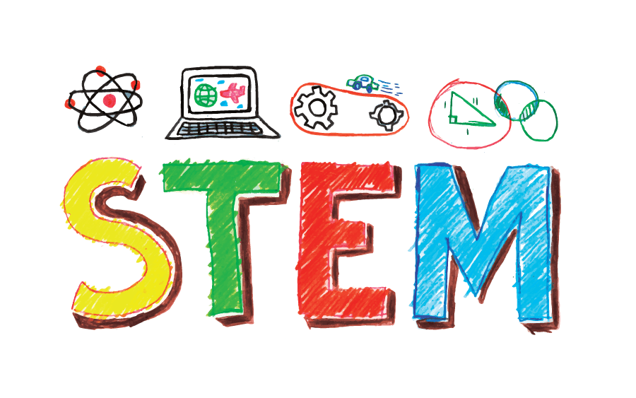
School age Daily Schedule
8:50am – 9:15am Morning Snack 2:30pm - 4:00pm Free play/ inside activities
9:15am – 10:00am Outside Play 4:00pm – 5:00pm Outside Play
10:00am – 11:30 Inside Activities 5:00pm – 6:00pm Front room/ Closing
11:30am- 12:00pm Lunch

12:00pm – 2:00pm Outside play/ Activities *All school age student must arrive by
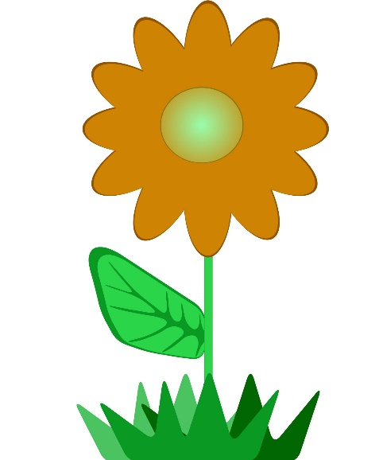
2:00pm – 2:30pm Afternoon Snack 9:15am during breaks. Thank you.

